Week-6 React Hands-On
9) cricketapp:
ListofPlayers.js:
import React from 'react';

const ListofPlayers = () => {
const players = [
{ name: 'Virat Kohli', score: 85 },
{ name: 'Rohit Sharma', score: 90 },
{ name: 'Shubman Gill', score: 67 },
{ name: 'KL Rahul', score: 72 },
{ name: 'Hardik Pandya', score: 45 },
{ name: 'Jadeja', score: 76 },
{ name: 'Ashwin', score: 34 },
{ name: 'Bumrah', score: 50 },
{ name: 'Shami', score: 95 },
{ name: 'Siraj', score: 81 },
{ name: 'Kuldeep', score: 62 },
];
const below70 = players.filter(player => player.score < 70);

return (
<div>
<h2>All Players</h2>
<ul>
{players.map((player, index) => (
<li key={index}>
{player.name} - {player.score}
</li>
))}
</ul>

<h2>Players with Score Below 70</h2>
<ul>
{below70.map((player, index) => (
<li key={index}>
{player.name} - {player.score}
</li>
))}
</ul>
</div>
);
};
export default ListofPlayers;

IndianPlayers.js:
import React from 'react';

const IndianPlayers = () => {
const players = ['Virat', 'Rohit', 'Gill', 'Rahul', 'Hardik', 'Jadeja', 'Ashwin', 'Bumrah', 'Shami', 'Siraj', 'Kuldeep'];
const oddTeam = players.filter((_, i) => i % 2 !== 0);
const evenTeam = players.filter((_, i) => i % 2 === 0);
const [p1, p2, p3, ...rest] = players;

return (
<div>
<h2>Even Team Players</h2>
<ul>
{evenTeam.map((player, index) => (
<li key={index}>{player}</li>
))}
</ul>
<h2>Odd Team Players</h2>
<ul>
{oddTeam.map((player, index) => (
<li key={index}>{player}</li>
))}
</ul>

<h2>List of Indian Players</h2>
<ul>
{players.map((player, index) => (
<li key={index}>{player}</li>
))}
</ul>
</div>
);
};
export default IndianPlayers;

App.js:
import React from 'react';
import ListofPlayers from './components/ListofPlayers';
import IndianPlayers from './components/IndianPlayers';

function App() {
const flag = true; // false
return (
<div className="App">
<h1>🏏 Cricket App</h1>
{flag ? <ListofPlayers /> : <IndianPlayers />}
</div>
);
}
export default App;

OUTPUT:
Flag==true
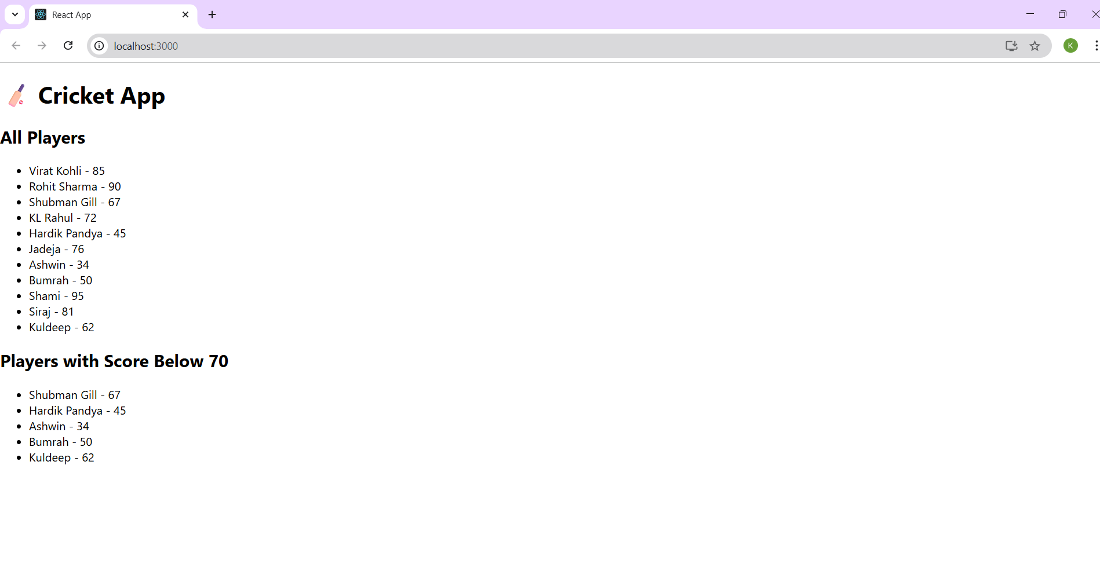Flag==false
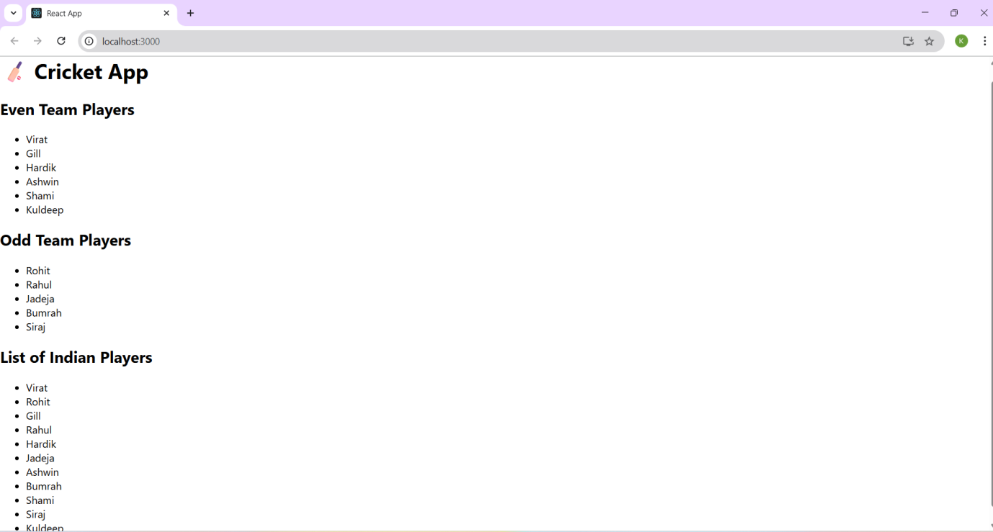

10) officespacerentalapp:
App.js:
import React from "react";
import "./App.css";
const officeSpaces = [
{
name: "Downtown Workspace",
rent: 45000,
address: "Bangalore",
image: "/img1.jpg"
},
{
name: "GreenTech Towers",
rent: 70000,
address: "Hyderabad",
image: "/img2.jpg"
},
{
name: "CyberHub Space",
rent: 62000,
address: "Chennai",
image: "/img3.jpg"
}
];

function App() {
return (
<div className="App">
<h1>Office Space Rental App</h1>

{officeSpaces.map((office, index) => (
<div key={index} className="office-card">
<img src={office.image} alt={office.name} />
<h2>{office.name}</h2>
<p>Address: {office.address}</p>
<p
style={{
color: office.rent > 60000 ? "green" : "red",
fontWeight: "bold"
}}
>
Rent: ₹{office.rent}
</p>
</div>
))}
</div>
);
}
export default App;

App.css:
.App {
text-align: center;
padding: 20px;
}

.office-card {
border: 1px solid #ccc;
padding: 15px;
margin: 20px auto;
width: 320px;
box-shadow: 0 0 10px rgba(0, 0, 0, 0.1);
border-radius: 8px;
}

.office-card img {
width: 100%;
height: auto;
border-radius: 6px;
}

OUTPUT:
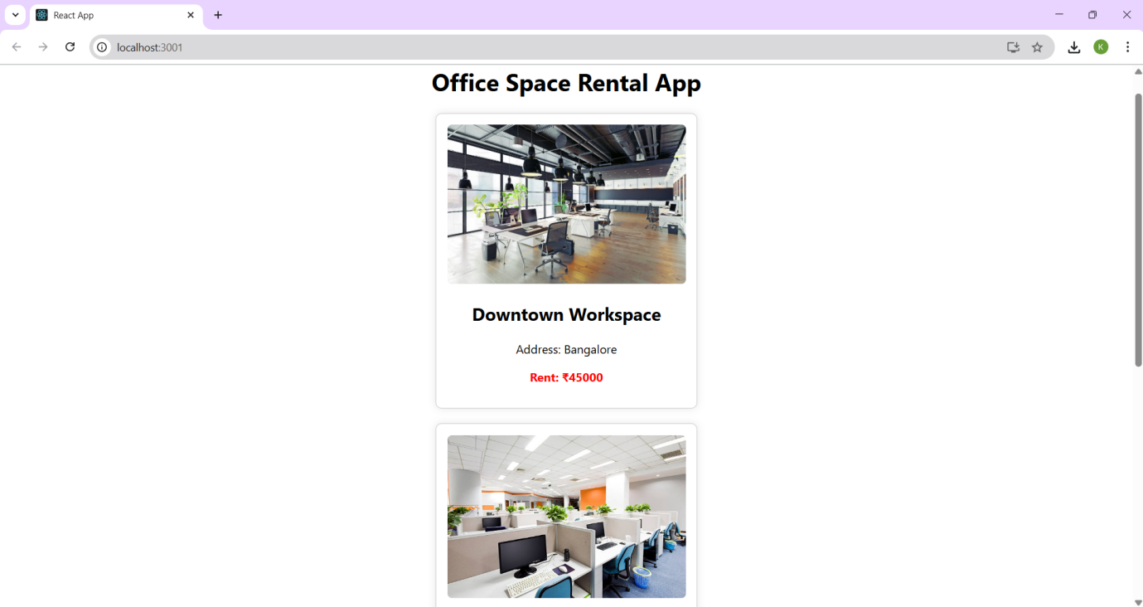

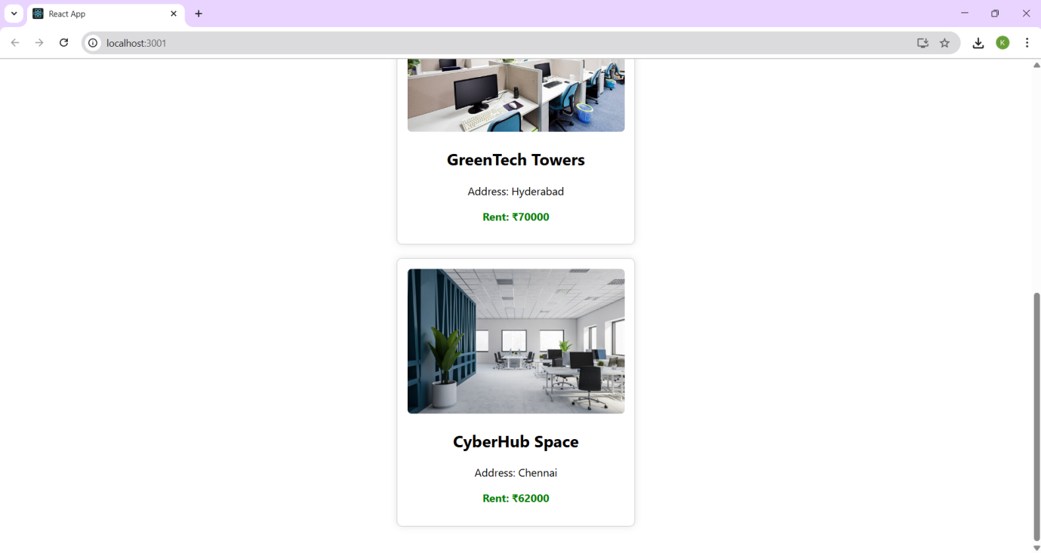

========================================================
11) eventexamplesapp:
App.js:
import React, { useState } from 'react';
import CurrencyConvertor from './CurrencyConvertor';

function App() {
const [count, setCount] = useState(0);

const sayHello = () => {
alert("Hello!");
};
const increment = () => {
setCount(prev => prev + 1);
sayHello();
};
const decrement = () => {
setCount(prev => prev - 1);
};

const sayWelcome = (message) => {
alert(message);
};

const handlePress = () => {
alert("I was clicked");
};

return (
<div style={{ padding: '20px' }}>
<h1>Event Examples App</h1>
<h2>Counter: {count}</h2>
<button onClick={increment}>Increment</button>
<button onClick={decrement}>Decrement</button>
<br /><br />
<button onClick={() => sayWelcome("Welcome!")}>Say Welcome</button>
<br /><br />

<button onClick={handlePress}>OnPress</button>
<br /><br />

<CurrencyConvertor />
</div>
);
}
export default App;

CurrencyConvertor.js:
import React, { useState } from 'react';

function CurrencyConvertor() {
const [rupees, setRupees] = useState('');
const [euro, setEuro] = useState('');

const handleSubmit = (e) => {
e.preventDefault();
const conversionRate = 0.011;
setEuro((parseFloat(rupees) * conversionRate).toFixed(2));
alert(“Converting to Euro Amount: “+euro);
};

return (
<div>
<h2>Currency Convertor</h2>
<form onSubmit={handleSubmit}>
<label>Enter amount in INR: </label>
<input
type="number"
value={rupees}
onChange={(e) => setRupees(e.target.value)}
/>
<button type="submit">Convert</button>
</form>
{euro && <h3>{rupees} INR = {euro} EUR</h3>}
</div>
);
}
export default CurrencyConvertor;
OUTPUT:
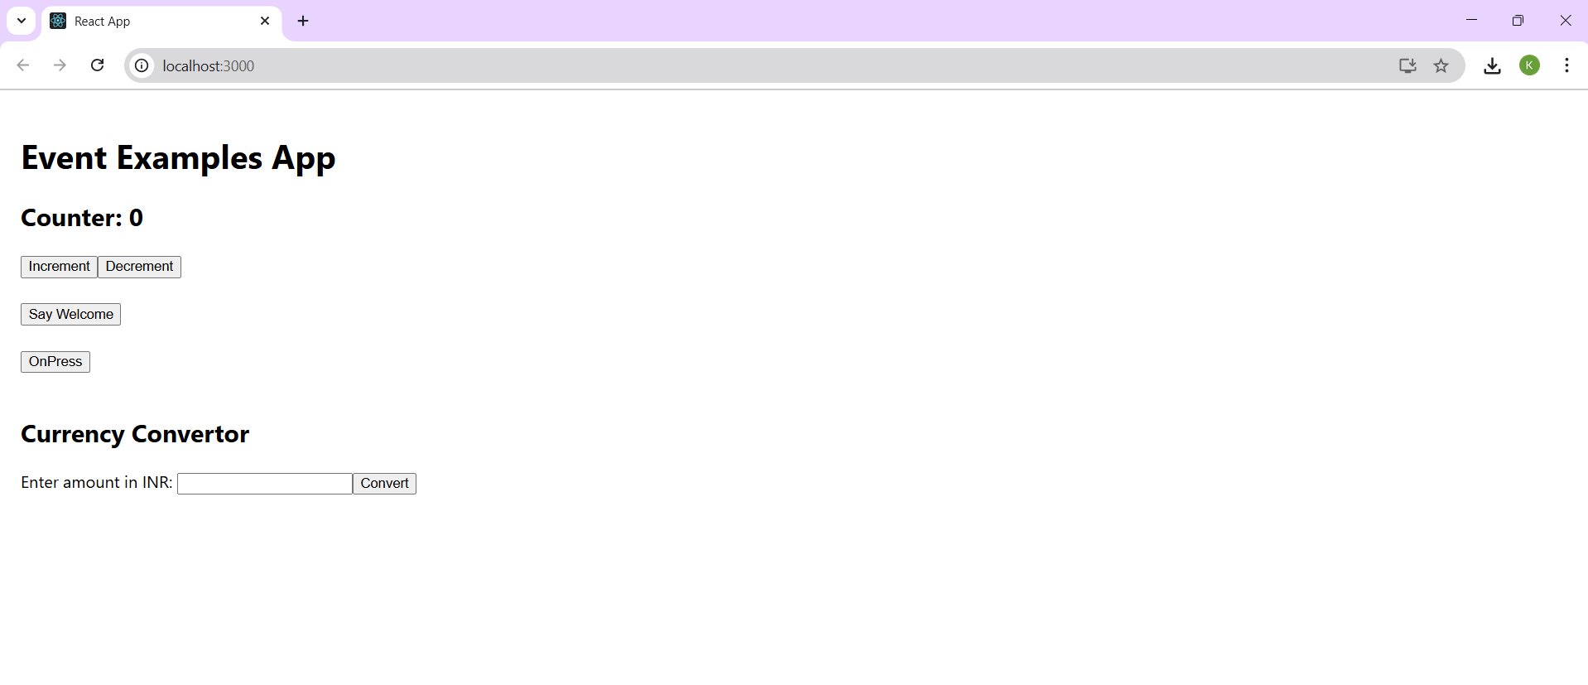
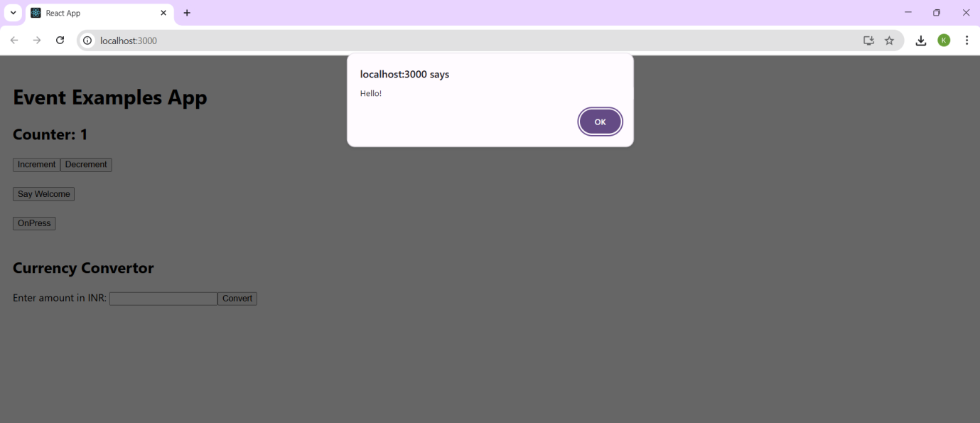

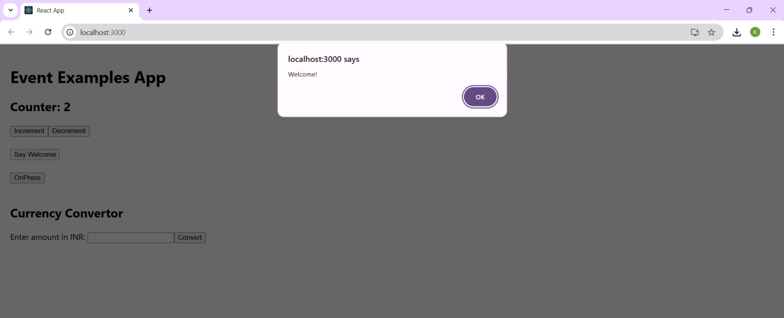

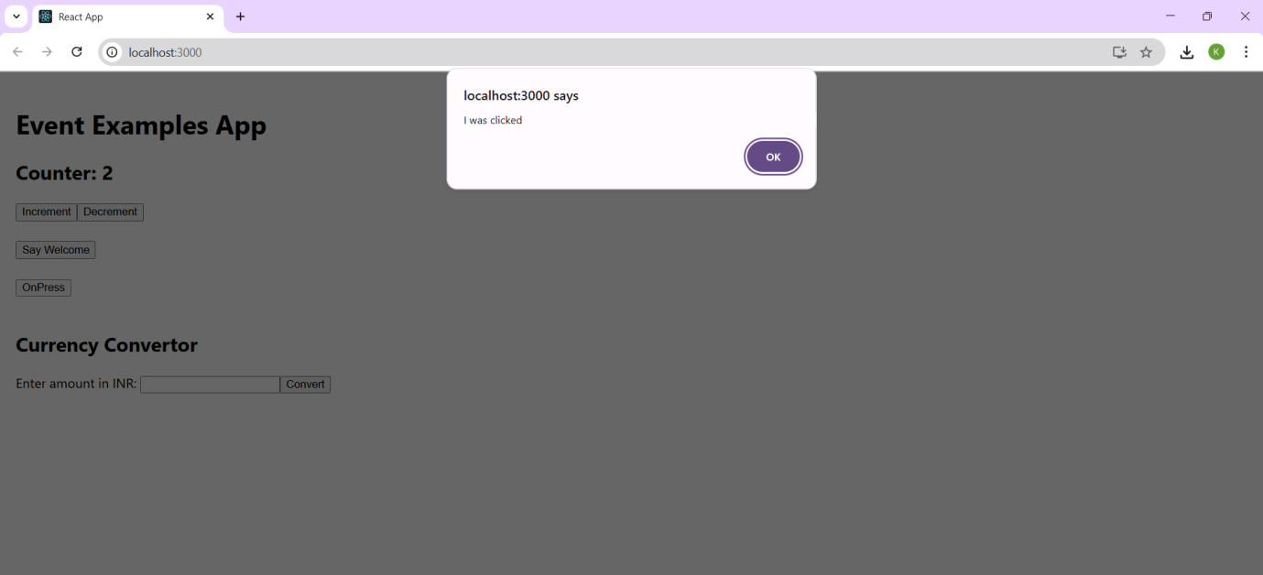

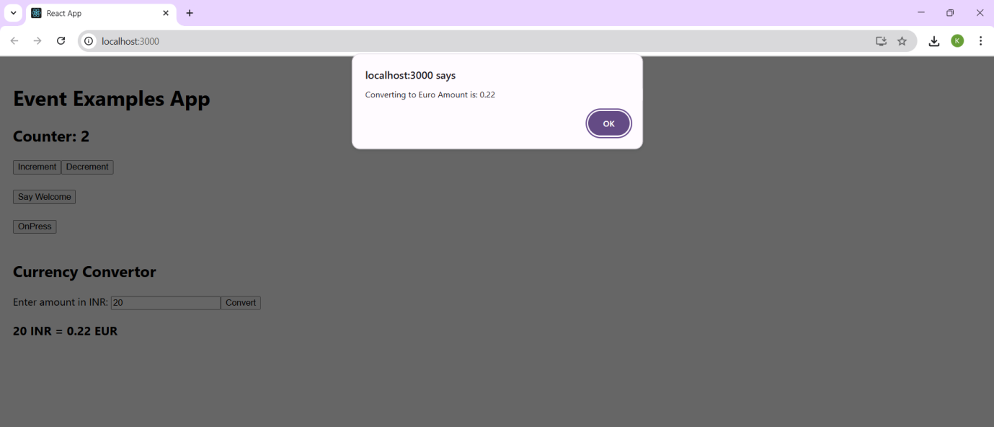

==================================================================================

12) ticketbookingapp:
GuestPage.js:
import React from 'react';
function GuestPage({ onLogin }) {
return (
<div>
<h2>Welcome, Guest!</h2>
<button onClick={onLogin}>Login</button>
</div>
);
}
export default GuestPage;

UserPage.js:
import React from 'react';
function UserPage({ onLogout }) {
const handleBook = (flight) => {
alert(`Ticket booked for flight: ${flight.name}`);
};

return (
<div>
<h2>Welcome, User!</h2>
<button onClick={onLogout}>Logout</button>
</div>
);
}
export default UserPage;

App.js:
import React, { useState } from 'react';
import GuestPage from './components/GuestPage';
import UserPage from './components/UserPage';

function App() {
const [isLoggedIn, setIsLoggedIn] = useState(false);

const handleLogin = () => setIsLoggedIn(true);
const handleLogout = () => setIsLoggedIn(false);

return (
<div>
{isLoggedIn ? (
<UserPage onLogout={handleLogout} />
) : (
<GuestPage onLogin={handleLogin} />
)}
</div>
);
}
export default App;

OUTPUT:
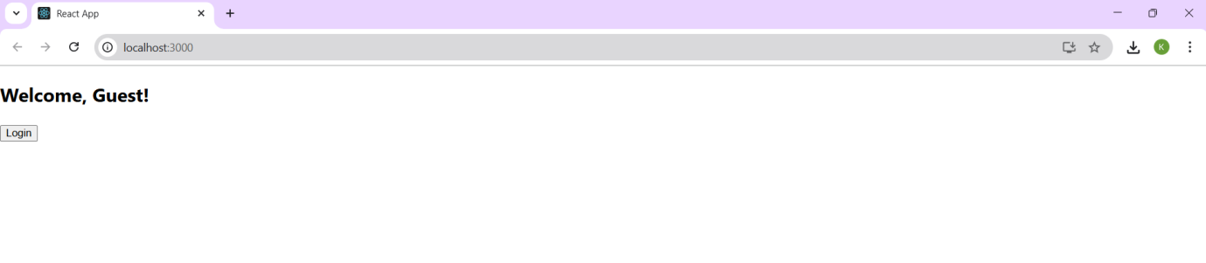

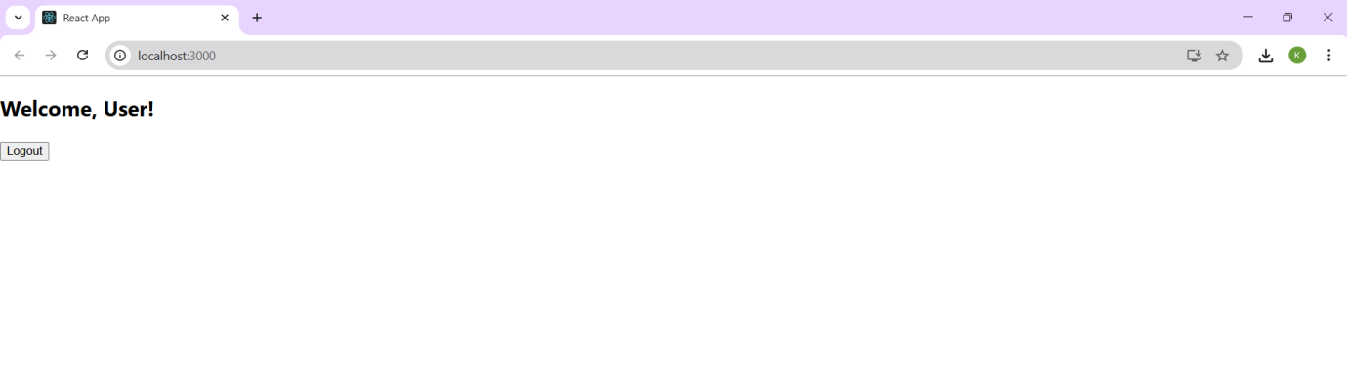

========================================================

13) bloggerapp:
CourseDetails.js:
import React from 'react';

const CourseDetails = () => {
const courses = [
{ name: 'Angular', date: '4/5/2021' },
{ name: 'React', date: '6/3/20201' },
];

return (
<div className="section">
<h2>Course Details</h2>
{courses.map((course, index) => (
<div key={index}>
<strong>{course.name}</strong>
<p>{course.date}</p>
</div>
))}
</div>
);
};
export default CourseDetails;

BookDetails.js:
import React from 'react';

const BookDetails = () => {
const books = [
{ title: 'Master React', price: 670 },
{ title: 'Deep Dive into Angular 11', price: 800 },
{ title: 'Mongo Essentials', price: 450 },
];

return (
<div className="section">
<h2>Book Details</h2>
{books.map((book, index) => (
<div key={index}>
<strong>{book.title}</strong>
<p>{book.price}</p>
</div>
))}
</div>
);
};
export default BookDetails;

BlogDetails.js:
import React from 'react';

const BlogDetails = () => {
const blogs = [
{
title: 'React Learning',
author: 'Stephen Biz',
content: 'Welcome to learning React!',
},
{
title: 'Installation',
author: 'Schwezdneier',
content: 'You can install React from npm.',
},
];

return (
<div className="section">
<h2>Blog Details</h2>
{blogs.map((blog, index) => (
<div key={index}>
<strong>{blog.title}</strong>
<p><em>{blog.author}</em></p>
<p>{blog.content}</p>
</div>
))}
</div>
);
};
export default BlogDetails;

App.js:
import React from 'react';
import CourseDetails from './components/CourseDetails';
import BookDetails from './components/BookDetails';
import BlogDetails from './components/BlogDetails';
import './App.css';

const App = () => {
return (
<div className="container">
<CourseDetails />
<div className="divider"></div>
<BookDetails />
<div className="divider"></div>
<BlogDetails />
</div>
);
};
export default App;

OUTPUT:




